**SMART HOME**

CIRCUIT:

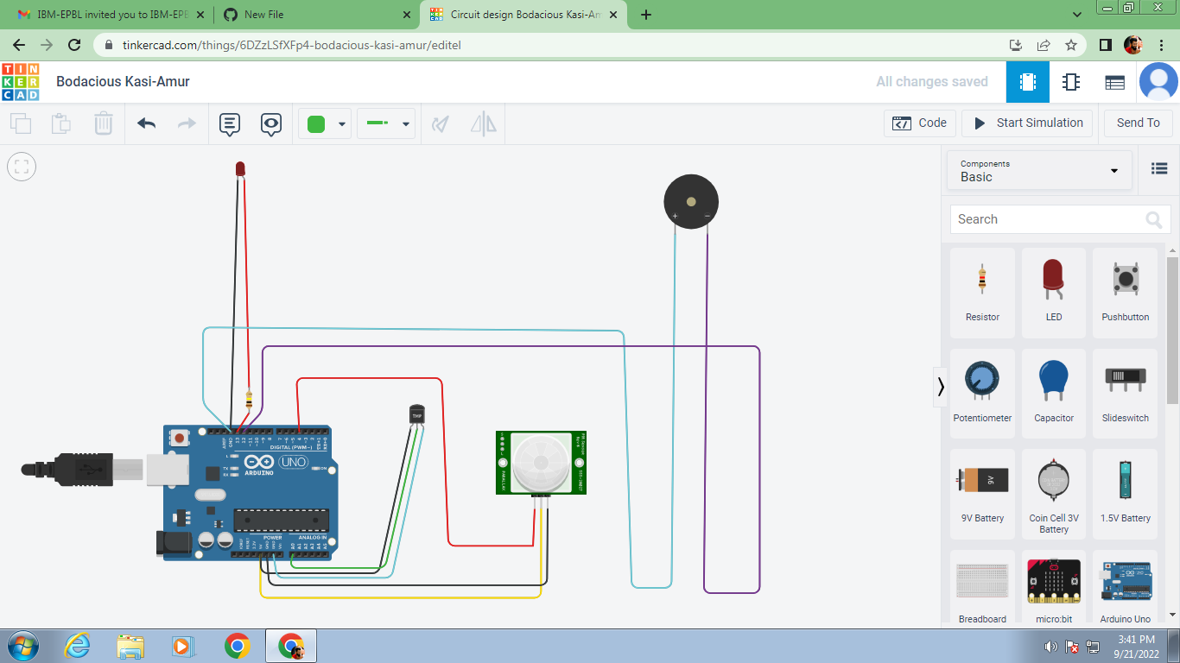

CIRCUIT EXPLANATION

The above circuit composed of Arduino, LED, Piezo Buzzer, PIR Sensor and the Temperature Sensor. The simulation of the circuits describes, When any movement is found near the PIR Sensor , the output describes that the Some movement is found. If the temperature sensor detects that the temperature of the sensor is above 37 degree, the Buzzer Sounds and the LED Glows high.

PROGRAM

//Smart Home//

void setup()

{

Serial.begin(9600);

pinMode(4,INPUT);

pinMode(13,OUTPUT);

pinMode(12,OUTPUT);

}

void loop()

{

int p=digitalRead(4);

Serial.println(p);

digitalWrite(13,LOW);

if(p)

{

double a= analogRead(A0);

double t=(((a/1024)*5)-0.5)*100;

Serial.print("Temperature Value");

Serial.println(t);

delay(1000);

if (t>=37)

Serial.println("Man Movement is Found!!!");

if(t>=37)

tone(12,20);

delay(1000);

digitalWrite(13,HIGH);

//For any movement in the surrounding//

Serial.println("Some Movement is found!!!");

}

delay(1000);

}

TINKERCAD LINK

<https://www.tinkercad.com/things/6DZzLSfXFp4-bodacious-kasi-amur>

**M.J.MAKESH**

**961819106036**

**Ponjesly College of Engineering**